**Lab 3 Report**

黃偉哲

107598019

2019/4/30

1. **Test Plan**
   1. **Test requirements**

The Lab 3 requires to (1) select 6 methods from 6 classes of the SUT (GeoProject), (2) design Unit test cases by using **basis path and graph coverage** technique for the selected methods, (3) develop test scripts to implement the test cases, (4) execute the test scripts on the selected methods, (5) report the test results, and (6) specify your experiences of designing test cases systematically using the ISP technique.

In particular, based on the statement and branch coverage criteria, the **test requirements** for Lab 3 are to design test cases *with* **basis path and/or graph coverage**for each selected method so that “*each statement and branch of the method will be covered by at least one test case* and *the both minimum* ***statement*** *(node) and* ***branch*** *(edge) coverage are 90%, respectively (greater than Lab 2)*”.

* 1. **Test Strategy**

To satisfy the test requirements listed in Section 1, a proposed strategy is to

1. select **those 3 methods that were chosen in Lab1 or Lab2** and **3 new methods** that are NOT selected previously. The selected methods MUST contain **predicate** and **loop** structures (as many as possible).
2. set the objective of the minimum statement coverage to be greater than that of Lab 2 and adjust the test objective based on the time available (if necessary).
3. design the test cases for those selected methods by using the **basis path and graph coverage** testing technique.
   1. **Test activities**

To implement the proposed strategy, the following activities are planned to perform.

|  |  |  |  |
| --- | --- | --- | --- |
| **No.** | **Activity Name** | **Plan hours** | **Schedule Date** |
| 1 | Study GeoProject | 0.5 | 2019/04/28 |
| 2 | Learn **basis path and graph coverage** | 1 | 2019/04/28 |
| 3 | Design test cases for the selected methods | 3 | 2019/04/30 |
| 4 | Implement test cases | 2 | 2019/04/30 |
| 5 | Perform tests | 1 | 2019/04/30 |
| 6 | Complete Lab2 report | 2 | 2019/5/1 |

* 1. **Design Approach**

The **basis path and graph coverage** technique will be used to design the test cases. Specifically, the control flow graph (CFG) of each selected method shall be drawn first, and the possible test paths that satisfy the test requirements (i.e., **statement (node) and branch (edge) coverage**) shall be derived from the CFG. The possible **inputs** and **expected outputs** for the derived test paths shall be computed for each selected method. *Add more test cases by considering to satisfy other coverage criteria, such as edge-pair, all-use, or prime-path coverage criteria.*

* 1. **Success criteria**

All test cases designed for the selected methods must pass (or 90% of all test cases must pass) and *both statement and branch coverage should have achieved at least 90%, respectively.*

1. **Test Design**

To fulfill the test requirements listed in section 1.1, the following methods are selected and corresponding test cases are designed.

|  |  |  |  |
| --- | --- | --- | --- |
| **Class :** Base32 | | **Method :** encodeBase32 |  |
| **Basis Path :**  P1: {n1, n2, n3, n4, n6, n7, n9},  P2: {n1, n2, n4, n5, n6, n7, n8},  P3: {n1, n2, n4, n6, n7, n9} | | |
| **No** | **Inputs** | **Expected Outputs** |
| 1 | i=88888, length=7 | "0002qts" |
| 2 | i=-89563, length=1 | "-2rfv" |
| 3 | i=-30, length=7 | "-000000y" |

|  |  |  |  |
| --- | --- | --- | --- |
| **Class :** Base32 | | **Method :** decodeBase32 |  |
| **Basis Path :**  P1: {n1, n2, n3, n5, n7},  P2: {n1, n2, n3, n5, n6, n7},  P3: {n1, n2, n3, n4, n3, n5, n6, n7} | | |
| **No** | **Inputs** | **Expected Outputs** |
| 4 | hash="w" | 28 |
| 5 | hash="-j" | -17 |
| 6 | hash="-29jk" | -75314 |

|  |  |  |  |
| --- | --- | --- | --- |
| **Class : GeoHash** | | **Method :** decodeHash |  |
| **Basis Path :**  P1: {n1, n2, n3, n12},  P2: {n1, n2, n3, n4, n5, n6, n3, n12},  P3: {n1, n2, n3, n4, n5, n6, n7, n8, n10, n11, n6, n3, n12},  P4: {n1, n2, n3, n4, n5, n6, n7, n8, n9, n11, n6, n3, n12} | | |
| **No** | **Inputs** | **Expected Outputs** |
| 7 | geohash="29jw" | LatLong  [lat=-38.232421875,  lon=-149.58984375] |

|  |  |  |  |
| --- | --- | --- | --- |
| **Class :** GeoHash | | **Method:** coverBoundingBoxMaxHashes |  |
| **Basis Path :**  P1: {n1, n2, n4, n5, n6, n7, n11, n5, n12}  P2: {n1, n2, n3, n4, n5, n6, n7, n8, n9},  P3: {n1, n2, n4, n5, n6, n7, n8, n10}, | | |
| **No** | **Inputs** | **Expected Outputs** |
| 8 | topLeftLat=25.0361156, topLeftLon=121.4639264, bottomRightLat=25.0289061, bottomRightLon=121.4889208, maxHashes=4 | "Coverage  [hashes=[wsqq7,wsqqk], ratio=21.434198480498]" |
| 9 | topLeftLat=1,  topLeftLon=-1, bottomRightLat=,-1 bottomRightLon=-1, maxHashes=1 | “” |
| 10 | topLeftLat=25.0361156, topLeftLon=-121.4639264, bottomRightLat=-25.0361156, bottomRightLon=-121.4639264, maxHashes=2 | "Coverage [hashes=[wsqq7vxmfw5y], ratio=Infinity]" |

|  |  |  |  |
| --- | --- | --- | --- |
| **Class :** GeoHash | | **Method :** gridAsString |  |
| **Basis Path :**  P1: {n1, n2, n3, n11}  P2: {n1, n2, n3, n4, n5, n10, n3, n11},  P3: {n1, n2, n3, n4, n5, n6, n7, n8, n5, n10, n3, n11},  P4: {n1, n2, n3, n4, n5, n6, n7, n9, n5, n10, n3, n11} | | |
| **No** | **Inputs** | **Expected Outputs** |
| 11 | hash="29jw", fromRight=-1,  fromBottom=3,toRight=-1,  toBottom=1,  highlightThese="29jw","29jy", "29jx" | “” |
| 12 | hash="29jw", fromRight=1,  fromBottom=3, toRight=-1,  toBottom=1,  highlightThese="29jw","29jy", "29jx" | “” |
| 13 | hash="29jw",fromRight=-1,  fromBottom=-1,toRight=-1,  toBottom=1,  highlightThese="29jw","29jy", "29jx" | "29jr \n" + "29jq \n" + "29jm \n" |
| 14 | hash="29jw", fromRight=-1,  fromBottom=,-1toRight=-1,  toBottom=1, highlightThese="29jq","29jy","29jx",  "29jt","29jr","29jm","29jz","29jv" | "29JR \n" + "29JQ \n" + "29JM \n" |  |

|  |  |  |  |
| --- | --- | --- | --- |
| **Class :** Geomem | | **Method :** find |  |
| **Basis Path :**  P1: {n1, n2, n4},  P2: {n1, n2, n3, n2, n4} | | |
| **No** | **Inputs** | **Expected Outputs** |
| 15 | topLeftLat=0, topLeftLon=0, bottomRightLat=0, bottomRightLon=0,  start=-1000000, finish=100000 | "[]" |
| 16 | topLeftLat=120, topLeftLon=-120, bottomRightLat=0, bottomRightLon=120, start=-1000000, finish=100000 | "[]" |

The details of the design are given below:

The Excel file of test cases…

1. **Test Implementation**

The design of test cases specified in Section 2 was implemented using JUnit 4. The test scripts of 3 selected test cases are given below. The rest of the test script implementations can be found in the [link](https://github.com) (or JUnit files).

|  |  |  |
| --- | --- | --- |
| **No.** | **Test method** | **Source test code** |
| 1 | public static Coverage coverBoundingBoxMaxHashes(  double topLeftLat, double topLeftLon, double bottomRightLat, double bottomRightLon, int maxHashes) |  |
| 2 | public Iterable<Info<T,R>> find(double topLeftLat, double topLeftLon, double bottomRightLat, double bottomRightLon, long start, long finish) |  |
| 3 | public static LatLong decodeHash(  String geohash) |  |

1. **Test Results**
   1. **JUnit test result snapshot**





* 1. **Code coverage snapshot**
* Coverage of each selected method



* Total coverage



* 1. **CI result snapshot (3 iterations for CI)**
* CI#1

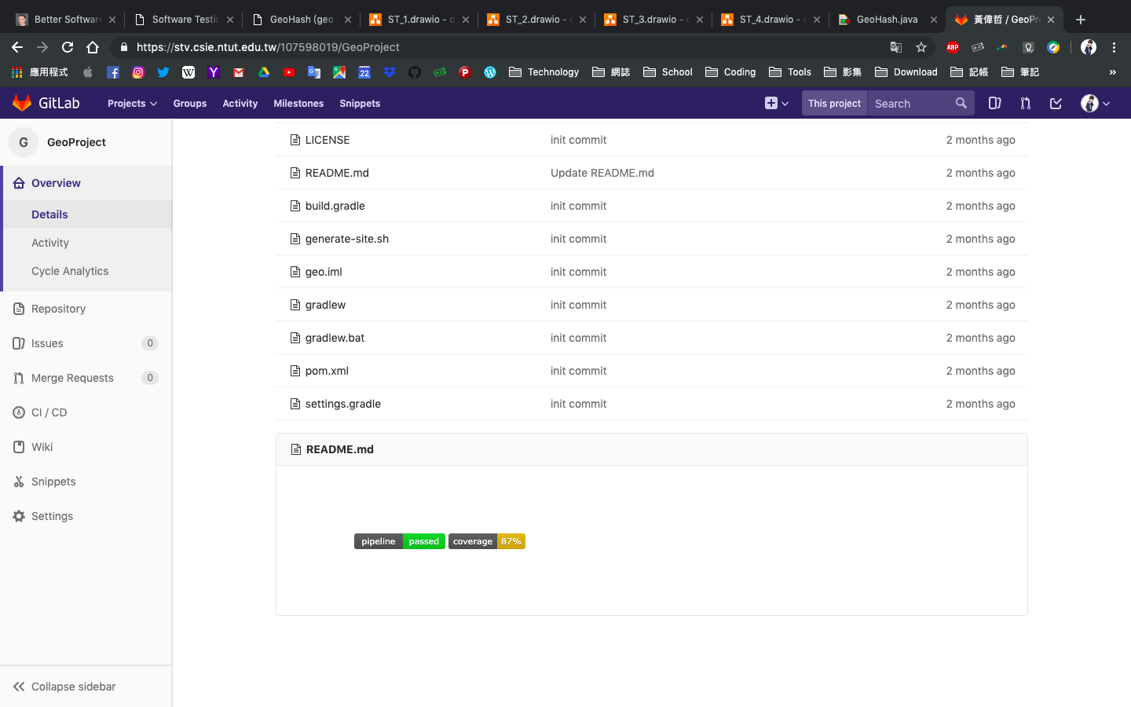

* CI#2

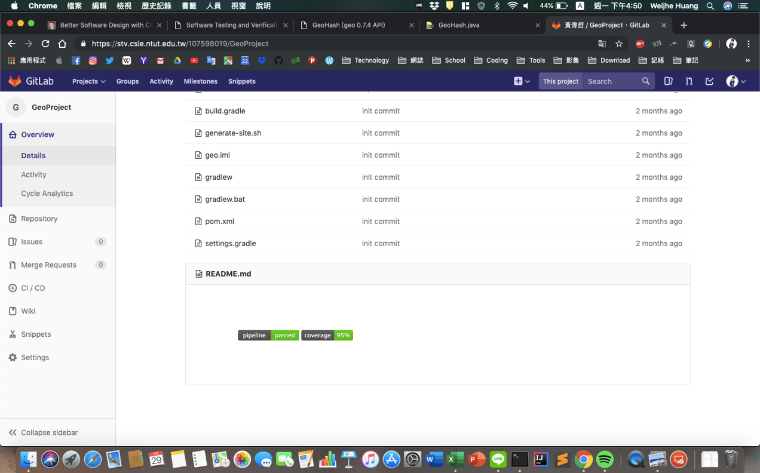

* CI#3

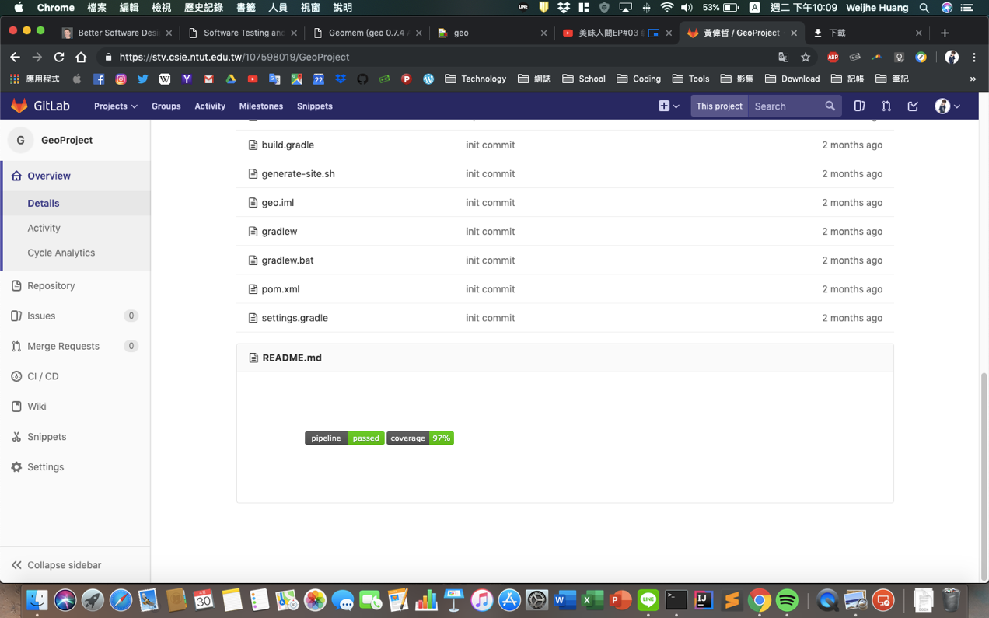

* CI Pipeline



1. **Summary**

從Lab 3的練習明顯可以測出更多結果，相較ISP似乎更能模擬出實際應用上會發生的問題。